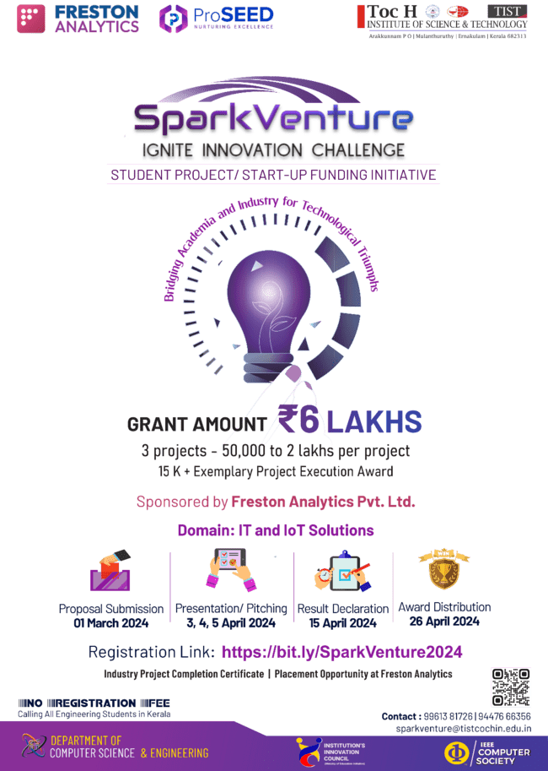

|  |  |
| --- | --- |
| Cyberpark, Kozhikode, Kerala, **India**  Parkside, London Road, Ipswich, **UK**  [**www.frestonanalytics.com/**](http://www.frestonanalytics.com/) | Department of Computer Science & Engineering,  Arakkunnam, Ernakulam, Kerala, Pin - 682313  [**www.tistcochin.edu.in**](http://www.tistcochin.edu.in) |

**REGISTRATION FORM**

**SECTION A: GENERAL INFORMATION**

Name and Address of the Institution :

Title of the Project Proposal :

**Project Team details**

Name of the Project Supervisor :

Department :

Designation :

Phone No. :

Email id :

Name of project team leader :

Semester :

Branch :

Phone No. :

Email id :

Other Team Members (Max Team size: 3)

|  |  |  |  |
| --- | --- | --- | --- |
|  | Member 1 | Member 2 | Member 3 |
| Name : |  |  |  |
| Semester : |  |  |  |
| Branch : |  |  |  |
| Phone No. : |  |  |  |
| Email Id : |  |  |  |

**SECTION B: TECHNICAL DETAILS**

Title of the proposed project :

Broad subject area/field of classification :

Project Type(s) :

*(Basic Research/Applied Research/Developmental/Demonstration/Start Up Venture/Others)*

Precise Objective of the project :

Expected Outcomes :

Abstract (300 Ch.) :

Methodology including the work plan :

Significance in the socioeconomic context :

Project – Product Conversion Feasibility :

Particulars of Equipment required :

Particulars of any other facilities required :

Whether the scheme was submitted to any other organization for financial support? :

*(If so, the names of the institutions and their decisions may be indicated.)*

Whether receiving support from any other organization at present?

*(If so, full particulars of these may be given.)*

**Budget** **Proposal** - Estimated Expenditure:

|  |  |  |
| --- | --- | --- |
| **Sl.No.** | **Item** | **Expenditure** |
|  |  |  |
|  |  |  |
|  |  |  |
|  |  |  |
|  |  |  |
| **Total Estimated Cost:** | |  |

**Terms and Conditions**

1. *‘SparkVenture - Ignite Innovation Challenge’* is a student project/start-up funding initiative instituted by Freston Analytics Private Limited (India, UK, Dubai) and ProSEED, conducted in association with the Department of CSE, IIC and IEEE Computer Society Chapter, Toc H Institute of Science and Technology, Arakkunnam.
2. The purpose of this is to provide assistance in the form of grants to engineering students in Kerala, for developing unique, useful and impactful projects that has a positive influence.
3. Grants of up to 2 lakh each will be allocated to a maximum of three projects shortlisted as per the evaluation criteria constituted by the organizers. The amount will be granted to the project team lead/ project supervisor in three stages as per the completion of milestones.
4. The start date of the project implementation is the 1st week of May 2024. The maximum duration of the project will be 7 months and should be completed by 25 November 2024.
5. On completion of the project, one copy of the project report along with the code should be submitted along with the certified bills, and statement of expenditure.
6. The ideas/projects submitted must be student-led initiatives and not an extension of faculty-led research or a non-governmental organization’s programs.
7. The institute shall not entrust the implementation of the work for which the grant is being sanctioned to a third party.
8. An expert panel will be constituted to review the work done after each milestone. Teams must be ready to modify the design/ implementation of their projects based on review suggestions.
9. The design of the proposed solution must consider project expenses and an implementation timeline.
10. Scores rendered by the judges will not be disclosed to the competition participants. The judge's decision is final, and no correspondence will be entered.
11. The organizers reserve all rights and authorities regarding all matters related to this event.
12. The organizers reserve the right to terminate the project at any stage if it is convinced that the grant has not been properly utilized or appropriate progress is not being made after each milestone.
13. Project teams are requested to get consent from the organizers before publishing papers emerging out of the project work in leading Journals. If so, the team must acknowledge the organizers in reports and technical/scientific papers publishing based on the work done under the project.
14. Freston Analytics Pvt. Ltd. will retain the intellectual property rights associated with the project/product, including any developed code.
15. The knowledge generated from the project will be the property of Freston Analytics Pvt. Ltd. and should be properly acknowledged. Transfer of technology generated shall be done in consultation with the organizers.
16. Each participant represents and warrants that he/she holds, and/or has obtained permission from any other person who has contributed to the projects, the projects must not violate any third-party rights, notably copyright.
17. Personal data is collected and processed solely for the purpose of managing and promoting the competition.
18. All participants will have to produce their identity cards if shortlisted.

We agree to the terms and conditions stated above.

|  |  |  |
| --- | --- | --- |
| Name & Signature of  Project Lead | Name & Signature of  Project Supervisor | Name & Signature of  Head of Department |